***National Agriculture Imagery Program (NAIP) Download Standard Operating Procedure (SOP)***

***What is the NAIP Download Program:***

*The NAIP Download program is a Python program which uses a JSON Web Token to gain access privileges to a known Box Account, in efforts to download zip files from the NAIP County Mosaic website (*[*https://nrcs.app.box.com/v/naip*](https://nrcs.app.box.com/v/naip)*). The NAIP Download program can function as both a manual and automatic program, depending on user preferences.*

***Objective of NAIP Download Program:***

*The objective of the NAIP Download program is to download all zip files uploaded onto the NAIP County Mosaic website within the previous seven days’ period.*

***Methodology of NAIP Download Program:***

*There are two primary ways to run the NAIP Download program:*

* ***Run from Anaconda Prompt***
  + *Manual run of the program.*
* ***Run from Windows Task Scheduler***
  + *Automatic run of the program.*

***\*\* The following are ‘step-by-step’ instructions for operating the NAIP Download Program. These procedures can be completed either within an Azure environment or within the base government computer \*\****

***Procedure – Manual Version (Anaconda Prompt Command Window):***

1. ***Open “Anaconda Prompt”.***
   1. *Open an Anaconda Prompt from your start / search menu.*

1. ***To run the program, type the following lines within the Anaconda Prompt Command Window. After each line, hit the ‘Enter’ key:***

Line 1: y:

Line 2: cd NAIP_download\Script

Line 3: python NAIP_Download.py

***Note:*** *The length of time for the USDA NAIP Download program to complete may depend on the amount of data available for download within the USDA NAIP Download site.*

***Note:*** *Make sure to minimize the command prompt window for the duration of the run.*

*\*\** ***Do not close the command prompt window or log off from the current session. \*\****

***Procedure – Automatic Version (Task Scheduler):***

1. ***Open “Task Scheduler”.***
   1. *Open Task Scheduler from your start / search menu.*

1. ***Create a standard task.***
   1. *In the Task Scheduler, click “Action” – “Create Task…”. The “Create Task” Panel will populate.*

1. ***Fill in desired parameters within the “Create Task” panel.***
   1. ***On the “Create Task” Panel, select the ‘General’ Tab at the top of the panel, and fill-in the following fields:***
      1. *Name = Display name for the created job.*
      2. *Description = Short description of the created job.*

***Note: Depending on account access, some parameters within this panel may not be changeable****.*

* 1. ***On the “Create Task” Panel, select the ‘Trigger’ Tab at the top of the panel, and fill-in the following fields:***
     1. *Select the “New” button, at the bottom of the panel.*
     2. *Fill-in the following parameters in the “New Trigger” Panel for the scheduled run and select OK.*
        1. *Identify Date and Time.*
        2. *Identify reoccurrence of run (One-time / Daily / Weekly / Monthly).*

***Note: Depending on account access, some parameters within this panel may not be changeable.***

* 1. ***On the “Create Task” Panel, select the ‘Action’ Tab at the top of the panel, and fill-in the following fields:***
     1. *Select the “New” button, at the bottom of the panel.*
     2. *Fill-in the following parameters in the “Edit Action” Panel for the scheduled run and select OK.*
        1. *Program/Script = C:\ProgramData\Anaconda3\python.exe*
        2. *Add Argument = Y:\NAIP_download\Script\NAIP_Download.py Identify*

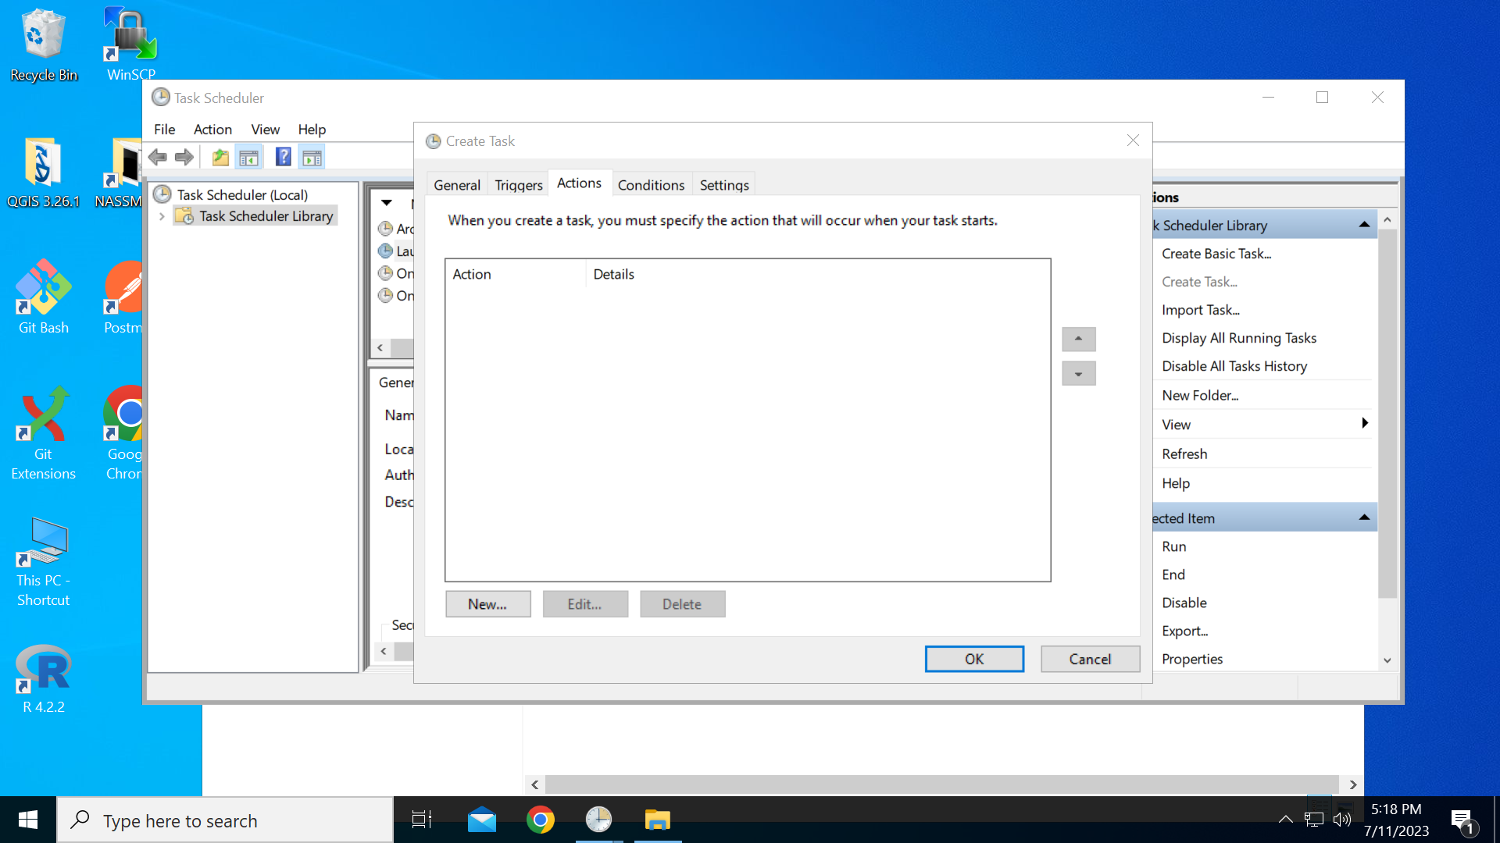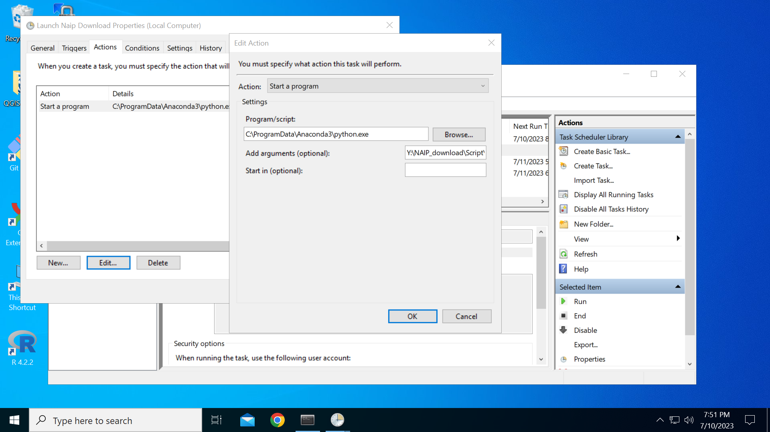

1. ***Once all necessary parameters are established, select the “OK” button on the “Create Task” Panel.***
2. ***When the designated time period occurs, a command prompt will appear signaling the begginning of the run.***

***Note:*** *The length of time for the USDA NAIP Download program to complete may depend on the amount of data available for download within the USDA NAIP Download site.*

***Note:*** *Make sure to minimize the command prompt window for the duration of the run.*

*\*\** ***Do not close the command prompt window or log off from the current session. \*\****